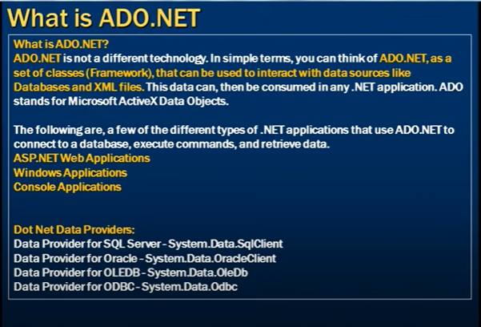

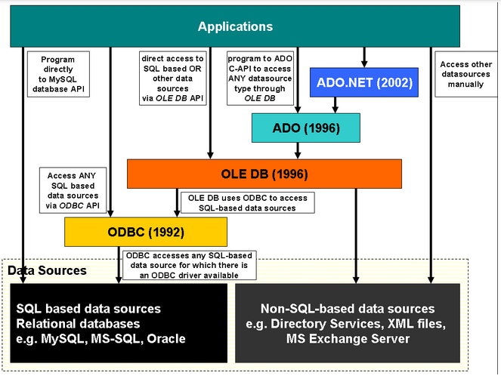

Data Providers in ADO.Net

1. SQL Data Provider (System.Data.SqlClient)
2. Oracle Data Provider (System.Data.OracleClient)
3. OleDB Data Provider (System.Data.OleDb) = Mainly Used to access MS Excel, MS Access
4. Entity Client Data Provider (System.Data.EntityClient)
5. ODBC Data Provider (System.Data.Odbc)

Top Objects

1. Connection
2. Command
3. Data Reader
4. Data Adaptor
5. DataSet (System.Data)

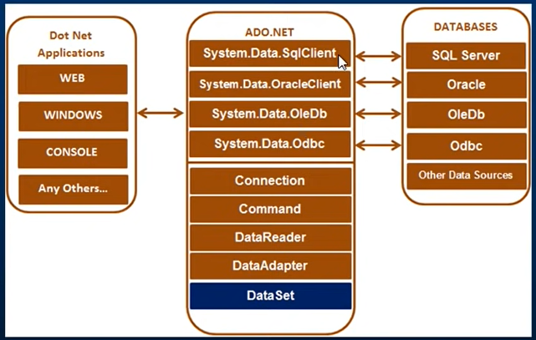

|  |  |
| --- | --- |
| Connection String In case of different Data Providers | SqlConnection connection = new SqlConnection("data source=.; database=FastPass; integrated security=SSPI;")  OdbcConnection connection = new OdbcConnection("Driver={Sql Server};Server=.;Database=FastPass;")  OleDbConnection connection = new OleDbConnection("Provider=SQLOLEDB;Data Source=.;Initial Catalog=FastPass; Integrated Security=SSPI;") |



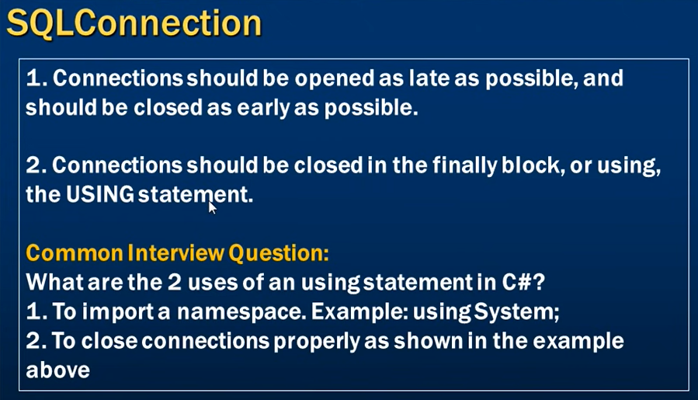

Read Connection String through web.config/app.config



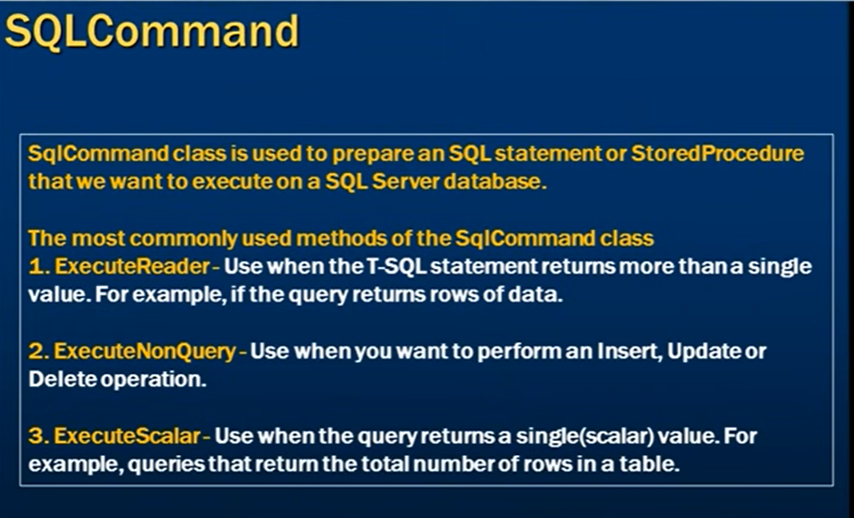

ExecuteNonQuery: returns int that is how many rows affected

ExecuteScaler: returns first column of first row ignoring every other cols/rows. And return type is object

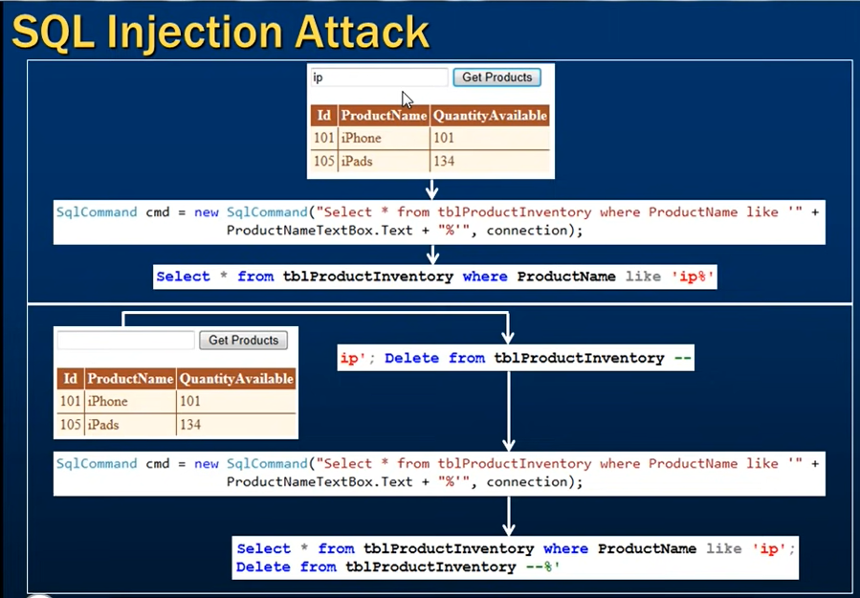

To avoid this, we should use Parameterized Queries or Stored Procedure

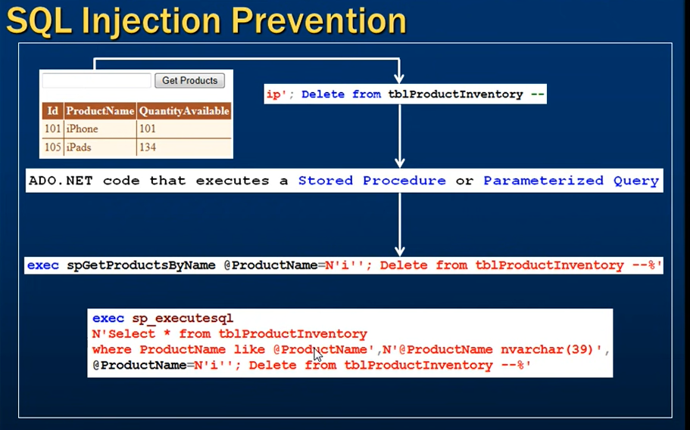

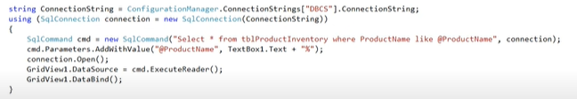

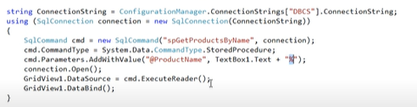

SQL Server Profiler can be found here:

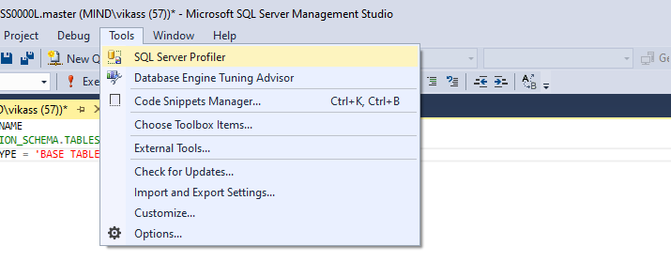

Execute Stored Procedure with “out” parameter:

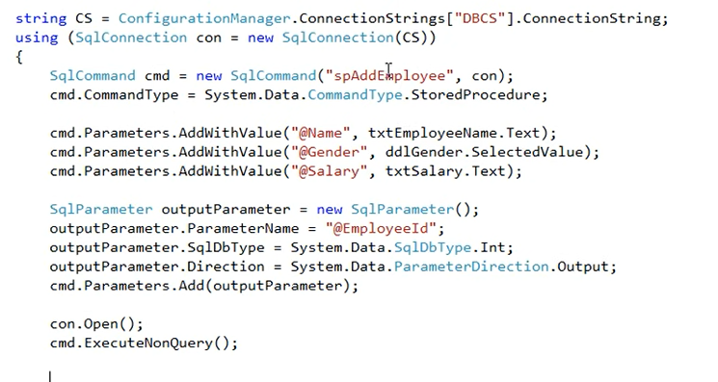

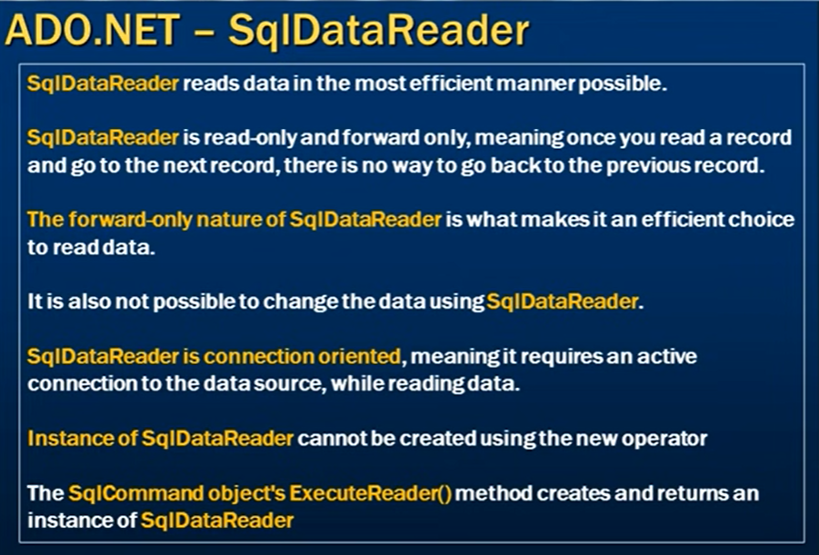

Loop through on SqlDataReader:

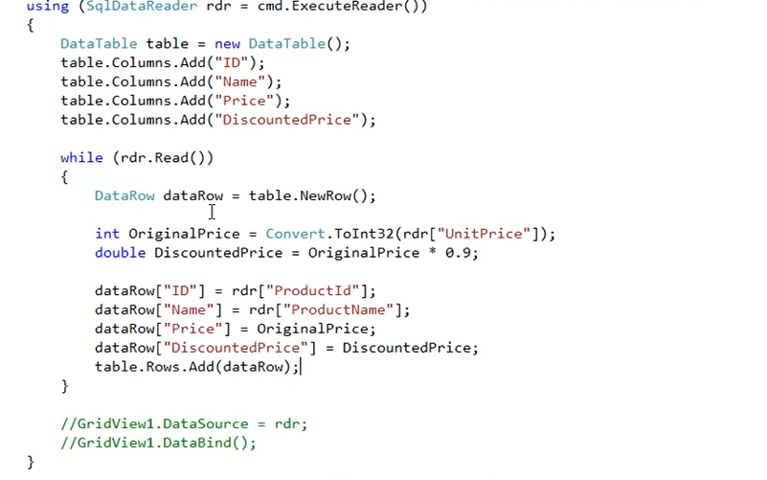

Multiple Result Set can be looped through NextResult:

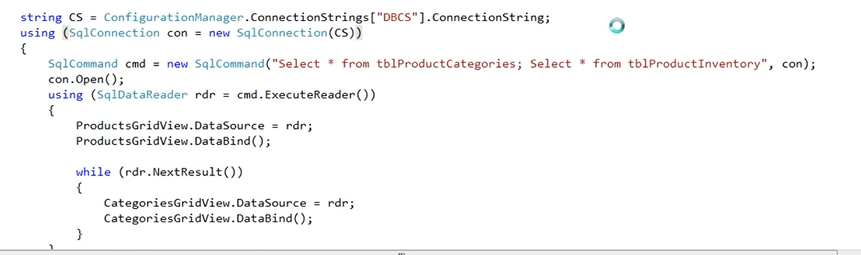

SQLDataAdapter

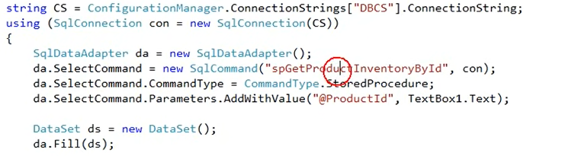

DataSet:

In memory representation of the Database

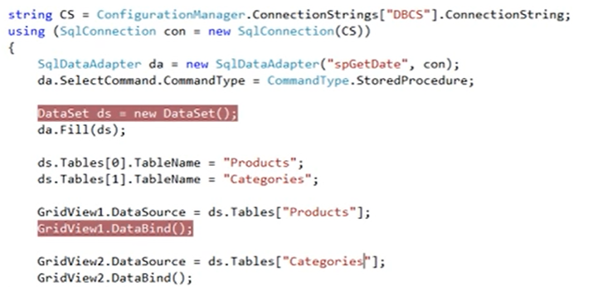



Cache Data Using Data Set

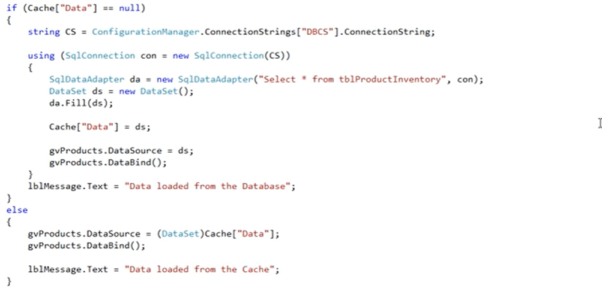

SQL Command Builder

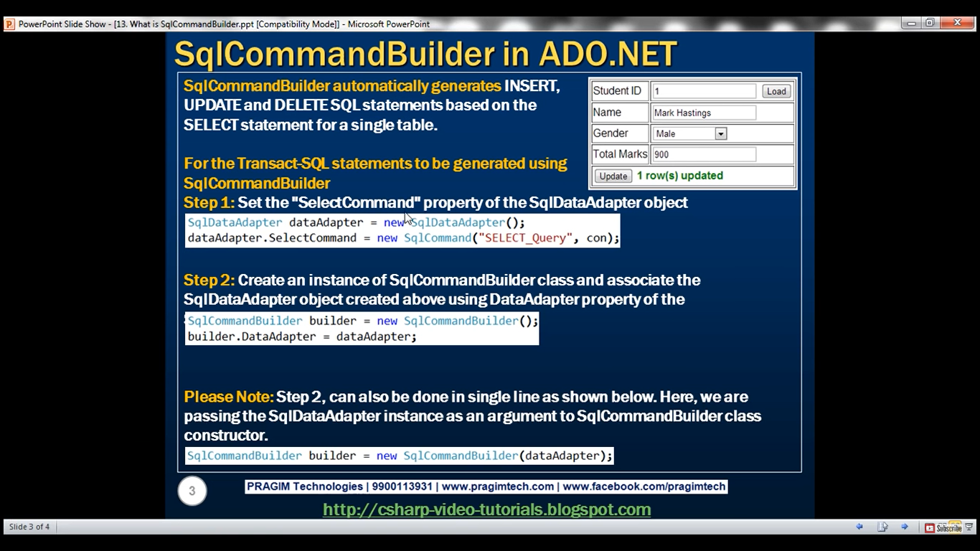

sda = new SqlDataAdapter("SELECT * from [Professors]", con);

SqlCommandBuilder.getDeleteCommand

INSERT INTO [Professors] ([ID], [Name], [Age], [Department]) VALUES (@p1, @p2, @p3, @p4)

DELETE FROM [Professors] WHERE (([ID] = @p1) AND ((@p2 = 1 AND [Name] IS NULL) OR ([Name] = @p3)) AND ((@p4 = 1 AND [Age] IS NULL) OR ([Age] = @p5)) AND ((@p6 = 1 AND [Department] IS NULL) OR ([Department] = @p7)))

UPDATE [Professors] SET [ID] = @p1, [Name] = @p2, [Age] = @p3, [Department] = @p4 WHERE (([ID] = @p5) AND ((@p6 = 1 AND [Name] IS NULL) OR ([Name] = @p7)) AND ((@p8 = 1 AND [Age] IS NULL) OR ([Age] = @p9)) AND ((@p10 = 1 AND [Department] IS NULL) OR ([Department] = @p11)))

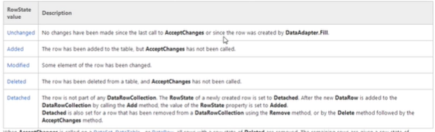

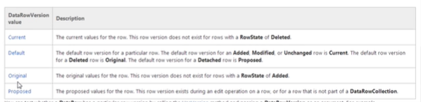

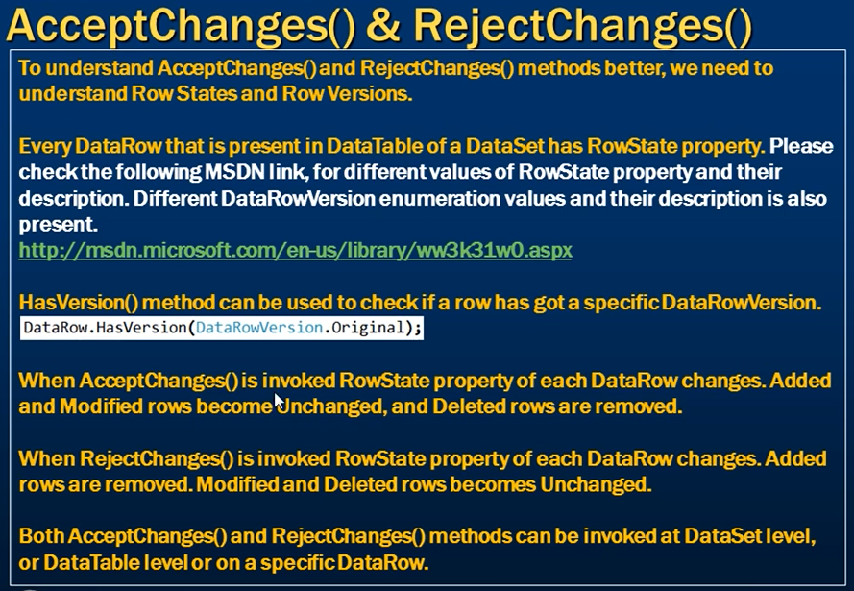

Strongly typed Data Set

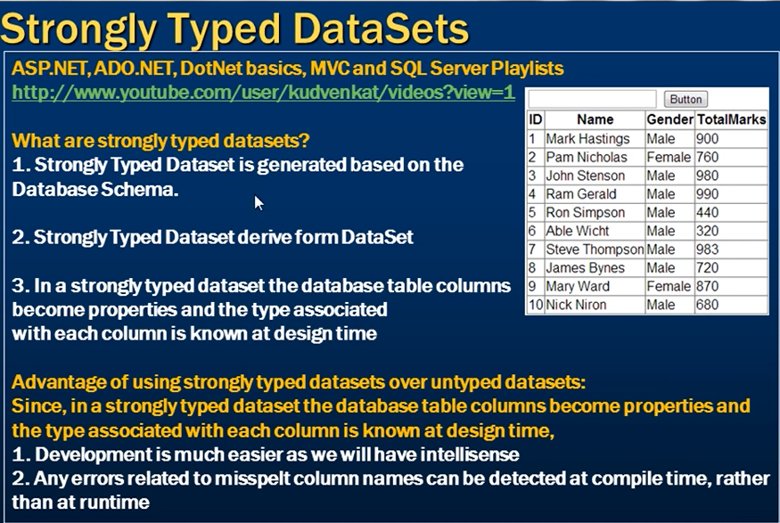

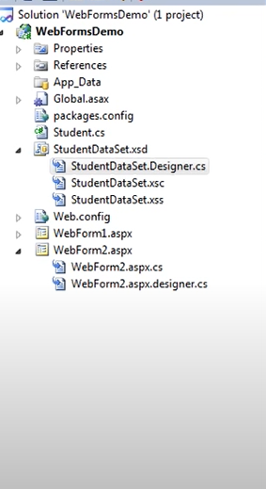

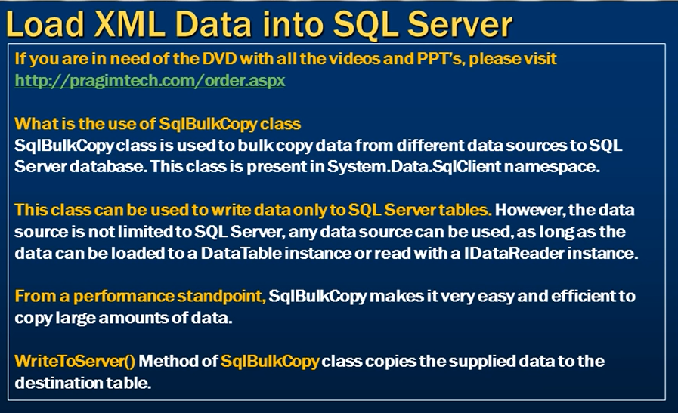

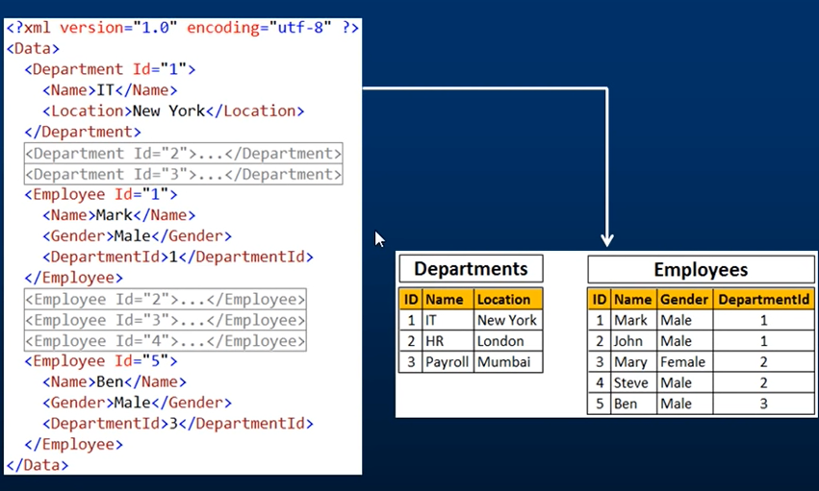

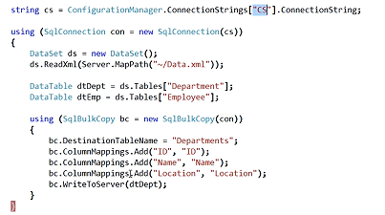

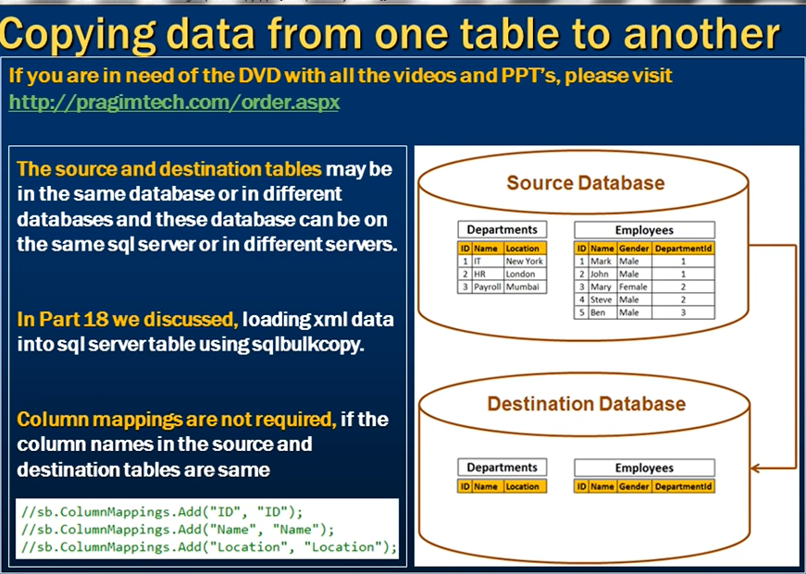

SqlDataReader are better than DataTable in case of reading data as DataReader are move-forward cursors

